1. 
2. 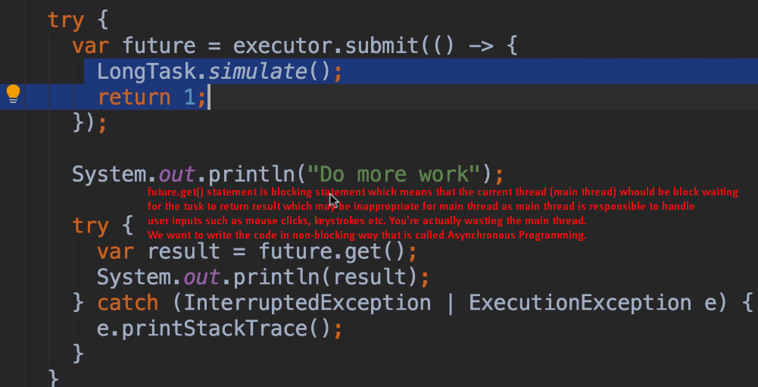
3. 
4. One thread should not wait for the other thread to finish.
5. In 2014, java gave us a tool to write asynchronous programming.